Chapter 5

RAMP-TRIM Users Manual

Correspondence Register and

Action Tracking

[and Attaching Electronic Items: Word, Excel, PDF Docs]

United Nations Children’s Fund
3 United Nations Plaza
New York, New York 10017

Chapter 5. Correspondence &
Item Register -Tracking

Table of Contents

1. Introduction and Concepts................................................................................................4
2. References…………….……………………………………………………………………….4
3. Register and Tracking Concepts 5
4. Registering Correspondence or other Items 5
4.1 Record Item Title [Required Field] 6
4.2 Author …………….. …………………………………………………………………...6
4.3 In, Out, Internal (Fd1) 7
4.4 Date Created…………...………………………………………………………………7
4.5 ExRef: Document Series/Year/Number 7
4.6 Date Due………………………...………………………………………………………7
4.7 Action…………….…..……………………………………………………………….…Error! Bookmark not defined.
4.8 Notes………………………………………...………………………………………..…7
4.9 Priority…………………………………...……………………………………………..7
4.10 DOS File Name………………………….…………………………………………….…7
4.11 Fg1: Current…………………………………….……………………………………8
4.12 Fg2: Status Certain? 8
4.13 Owner Location……………………………………………………………………...…8
4.14 Current Location…………………………………………………………………..…..8
5. Modify registered item 9
6. Containers/Local Folders 10
7. Relationships………................…………………………………………………… …………...12
8. Completing an Item Tracking Task 13
9. Finding the Status of an Item Tracking Tasks 14
10. Saved Searches……………………………………………………..……………………….…..15
11. Modifying Item Tracking Assignments 17
12. Attaching Electronic Documents 17
13. Printing Item Tracking Reports 20
14. Key Learning points 21
15. Self-Test: Document Tracking – Part A 22
16. Self-Test: Document Tracking – Part B 23
17. Exercises for Practice of Correspondence Tracking 25
18. Answers to Self-Test Document Tracking, Number 13 26

List of Figures

Figure 1. Main Menu Functions …………………………………………………………………..5
Figure 2 Correspondence or other Item Registration Entry Form………………………………….6
Figure 3. Modifying a Registered Item…………………………………………………………….8
Figure 4. Modifying Extra Details…………………………………………………………………9
Figure 5. Container Menu [used for local folders when registering items]………………………..13
Figure 6. Container/Local Folder Entry Form ……………………………………………………14
Figure 7. Relationship Form………………………………………………………………………Error! Bookmark not defined.
Figure 8. Menu Selection for Complete Current Action…………………………………………..Error! Bookmark not defined.
Figure 9. Browse Actions and Procedures………………………………………………………...16
Figure 10. Correspondence or Item Tracking Search…..…………………………………………14
Figure 11. Saved Searches……………………………………………………………………….. 15
Figure 12. Correspondence or Other Item Registration Entry Form……………………………… 17
Figure 13. Select Input File………………………………………………………………………. 18
Figure 14. Icon Indicating Word Document Attachment…………………………………………. 18
Figure 15. Extracting Document from TRIM to Store…………………………………………….19
Figure 16. TRIM to Store Overwrite Option………………………………………………………20
Figure 17. Returning Document to Store………………………………………………………….20

Introduction and Concepts
Tracking correspondence and correspondence items is performed for many reasons. You might find it necessary to identify events that are scheduled or perhaps actions that are overdue. It may be necessary to manage a large volume of incoming information, or in reference to document processing tasks, it may be important to know who has been assigned a task, when it is to be completed, when it was received. These are but a few possible interests and you will have others.

Correspondence and other items [e.g. reports and working papers] entering the organization or created within the organization will typically go through a number of steps before becoming an inactive record. These steps are managed electronic document creation, action tracking and workflow.

These procedures cover registering a new correspondence or other item record, completing a tracking task, finding the status of a tracking task, modifying tracking assignments and printing item logs and tracking reports.

References
The RAMP-TRIM manual chapters 1 through 3 describe basic navigation procedures, record searching, and management of series records. Review these documents before beginning Correspondence and Item Register and Tracking Concepts.

Chapter 1 | Overview or RAMP-TRIM and Organization Work Unit | CF/NYH/EPP/RAM/2000-131
Chapter 2 | Series of Records | CF/NYH/EPP/RAM/2000-132
Chapter 3 | Folder Listing | CF/NYH/EPP/RAM/2000-276
Chapter 4 | Shipment/Transfer - Box/Container | CF/NYH/EPP/RAM/2000-134
Annex A | Procedures for Quick Entry [Getting to Know RAMP-TRIM] | CF/NYH/EPP/RAM/2000-129
Annex B | Find Records Basic B-1 | CF/NYH/EPP/RAM/2000-129

This chapter of the manual describes methods of creating new correspondence items in RAMP-TRIM, assigning correspondence tracking processes, managing the tracking activity and reporting.

The following terms are used in this document and definitions are provided here for reference purposes.

Action A single step in a correspondence process
Procedure Two or more steps required to complete the correspondence tracking task
Kwikselect The yellow folder icon placed to the right of a field and used to access an authority
Record View Pane The portion of the search result displayed under the record list.
Workflow A process consisting of a number of Actions. Each of the actions must be completed for the record to have been successfully processed.

Register and Tracking Concepts
Tracking assignments set in motion a sequence of actions that must be completed before a record is considered to have been completely processed. A tracking task or tracking procedure can be assigned to a correspondence item at the time of creation or anytime after creation.

Registering Correspondence or other Items
Tracking usually begins with the registration of a new Correspondence or other Item record. Navigate to the menu path File, New Record and Item Correspondence.

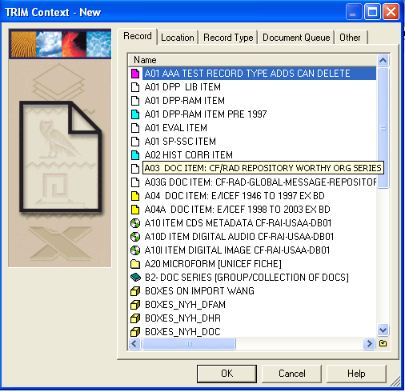

Figure 1. File New Item

Fill in the fields presented on the form using the following descriptions as a guide. Some fields are required [R], have default values [D], are optional [O] or have a combination of both.

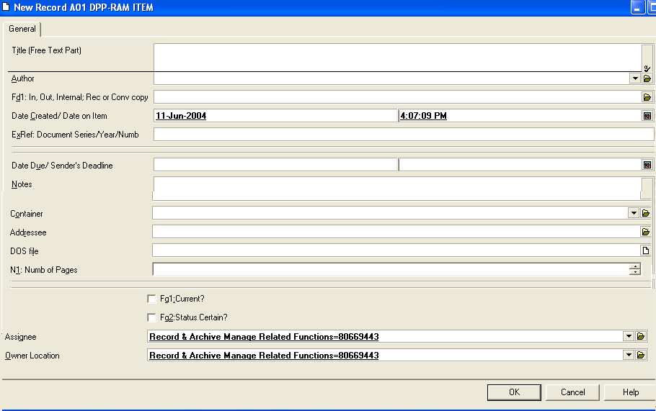
Figure 2 Correspondence or other Item Registration Entry Form

4.1 Record Item Title [R]
Enter a text title of your choice up to 256 alpha-numeric characters in length.

4.2 Author [O]
Select an authorized author using the yellow Kwikselect folder to display an alphabetical author list. Optionally, on display of the alphabetical list, select the Search button, enter the author’s last name in the field titled Resolve Matching Names, or Combine One of the Following Fields and select Do Search to display a list of authors sorted by last name. As in the previous search, highlight the correct name and select OK. Or you can simply type in the last name in the Author field of the General Tab and then click on the Kwikselect folder. All names refering to your choice appear, select the correct one.

If it is the case that the item is incoming from an organization outside of UNICEF, the Author refers to the name of the person who sent the material, not the staff member entering the material in RAMP-TRIM. RAMP-TRIM is able to maintain a list of such authors. It is advisable to first type in the name of the author [sender]. Go then to the Kwikselect button to see if the author’s name has already been entered into RAMP-TRIM. If the name of the person/organization does not appear, right click in the contact view pane and select “New Location”. A “Name” menu will appear where you can enter the details of the pertinent person/organization. Click OK and RAMP-TRIM will save the reference.

4.3 In, Out, Internal (Fd1) [O] Sender Reference (Fd2) [O]
The field titled In signifies correspondence coming into your specific work unit. The field titled Out signifies correspondence leaving your specific work unit, either within UNICEF or external to UNICEF. The field titled Internal signifies the record is for use within your specific work unit (division or section), passing from one person to another within your section. Consider preparing a guideline document for reference purposes in your work area. The Sender Reference and Cross Reference allow you to add a 33 alpha-numeric code for cross referencing purposes

4.4 Date Created [D/R]
The Date Created field is automatically populated with today’s date. You will enter the date the correspondence was created, usually the date on the incoming correspondence [the date created may not be the RAMP-TRIM registration date]. You must enter the full year, e.g. 12-May-2004. Use the Kwikselect Calendar on the right.

4.5 ExRef (ExID): Document Series/Year/Number [O]
Enter information that has lasting value to manage the correspondence (for example, previously used document numbers from another work unit). The field is limited to 50 alpha-numeric characters, e.g. CF/EXD/1997-001 or E/ICEF/1998-003. At the item level, the ExRef is optional, for all other levels, strongly recommended.

4.6 Date Fields [O] and Additional Dates
Date Published: Enter the date of publication 12-May-2002. Date Received and Date Distributed refer to action tracking. [Additional Date fields can be accessed after saving the record, then right clicking on the saved record, and going to Details/Dates. Click on the check box to make the fields active. Many of the fields refer to additional action tracking dates and retention and destruction dates.]

4.8 Notes [O]
Enter information that describes the records and that has long term value in the context of this record. You can enter up to approximately 30,000 characters or 32Kb into this field. The field cannot be formatted like a word processing record, though it is quite large in size.

4.9 Container record [O]
The container record refers to the folder, in which the item would be electronically attached.

4.10 Addressee [O]
The addressee refers to the person/organization to which the item is addressed.

4.11 DOS File Name
Leave this field blank if: 1) you are working with hardcopy [paper] records, or 2) you have catalogued the record through RAMP-TRIM TopDrawer software.

Use this field if the document is an electronic record and located on a server outside of RAMP-TRIM. Use the KwikSelect and navigate the path to the correspondence document.

4.12 Nu1: Number of Pages Current [O]
Fill in number of pages as appropriate.

4.13 Current Location/Assignee [R/D]
The organization, unit or individual currently holding correspondence item. The field value will default to the division, unit or organisation. Use the Kwikselect feature to identify the value in the organisation directory (locations).

4.14 Fg1: Current [O]
Enter a checkmark if the document status is current. That is, if the present version of the document is the most recent, e.g. revision, addendum. If not, leave the check box blank.

4.15 Fg2: Status Certain? [O]
Enter a checkmark if you are certain of the document status. If you are not certain of the status leave the check box blank.

4.16 Owner Location [R/D]
The organization, unit or individual responsible for the correspondence item. The field value will default to the division, unit or organisation. Use the Kwikselect feature to identify the value in the organisation directory (locations).

Note that most fields are not required, (and not all are programmed for individual record types). However the greater a level of description may make it easier to locate documents at a later time.

Modify registered item
  - Modify item title

Task/Modify/Title

Tag the TRIM item record whose title is to be edited. To modify an item title go to File/Properties, or Right Click/Properties. Go to the General Tabbed Page, then modify title to make the desired changes to the highlighted text. Click on OK to save the changes to the item title. Go to additional tabs for corresponding edits. Go to the data viewing area, right click, and select ‘new’ or other appropriate actions. As new data are added, additional tabs will appear. Use the right arrow below to view.

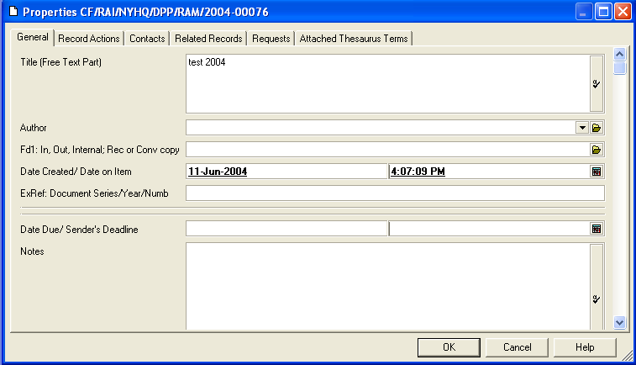

Figure 3. Modifying a Registered Item

  - Modify extra details -- Right Click/Details/User Fields or Details/Dates
To modify extra details, right click on an item, navigate to Details and select User Fields or Dates as appropriate. Here you will find the ‘External ID’ field for modification.
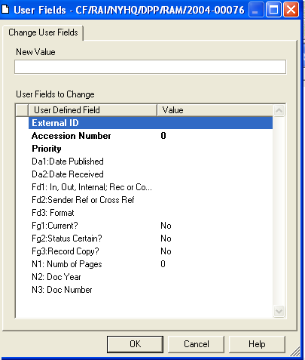
Figure 4. Modifying Extra Details

Containers/Local Folders
Correspondence Items should be placed in a folder – also called a container in RAMP-TRIM - for retrieval purposes. Folders help to manage all kinds of records, whether they are correspondence, reports or working papers. Records for these items can be placed within a specific folder as a primary grouping.

Unlike traditional paper folders, RAMP-TRIM folders can manage records created in different media. For example, a Water Resources Folder might contain correspondence created within Unicef on word processing systems, correspondence received via facsimile and paper, resource analysis in hardcopy with notes, research data in a database format. Basically RAMP-TRIM folders may manage any record media [e.g., paper, electronic, CD, microfilm, etc.]

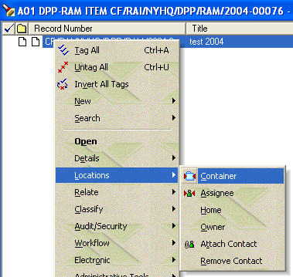

Figure 5. Right Click/Locations/Container.

Create a folder and the correspondence item. Display the correspondence item through a search. Right Click/Locations and the Container form is presented. Enter the folder number, or search for the container number, check the Enclose Record Now radio button and Ok. The correspondence is now contained – virtually contained this is – within the folders.
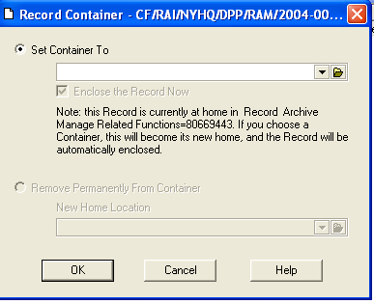
Figure 6. Container/Local Folder Entry Form
You can see the related container in one of two ways. Display the field Container Record number in the lower Record View Pane; or, from the upper Record List Pane with the record highlighted, right click the mouse, and select Navigate and Container Records. Navigate and Container/Contained Records can also be accessed through the main Search menu.

Once the folder is displayed, you can also choose Navigate and Container Records to see a complete list of records within the folder.

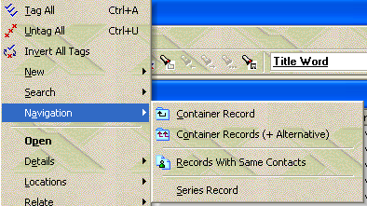

Figure 7. Container/Local Folder Entry Form

Relate
The feature may be useful to relate a correspondence or item to another item or to another folder. Items can be related as one that supersedes, one that is a copy of another item, an item that is the next part, or simply items that are related perhaps by activity function or purpose. [For example if you have “contained” an item in one folder, you may also relate it to other folders; similar to placing copies in multiple folders for an item which covered many subjects.]

Create correspondence item relationships in the following sequence. Search for and highlight the desired correspondence item, right click, navigate to Relate, enter the RAMP-TRIM record number in the lower With Record field or use the KwikSelect to search for the record. Designate the Relationship Type in the upper field [e.g., Related, Copy, Supersedes, or Next Part etc], and select Ok to save the relationship settings.
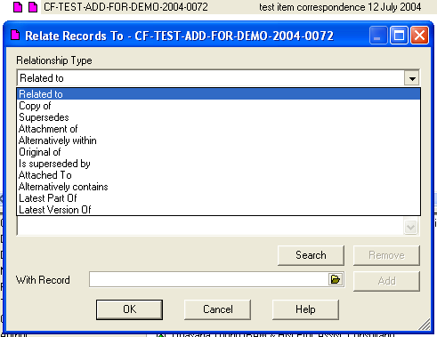
Figure 7. Relationship Form

Identify the relationship by right clicking/Properties/Related Records Tab. Right click in the data viewing area to perform additional functions for related records.

Completing an Item Tracking Task
Complete the Current Action You will receive notification of a correspondence action via Search/Trim Trays/Records In-Tray. To complete a correspondence tracking step or process step, Right Click on the item and go to Workflow/Browse Actions, or Right Click/Properties/Record Actions tab. Right click on the action and choose the appropriate step.

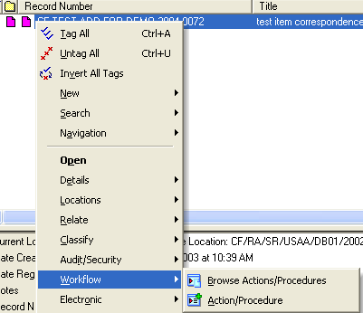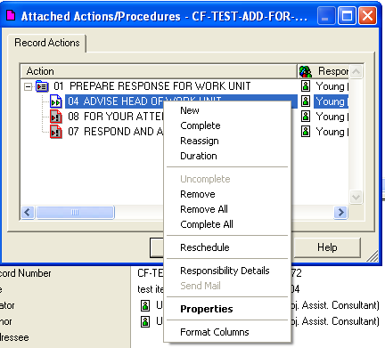

Figure 8 and 9. Right Click/Work Flow/Browse Action/Procedures and Right Click on Action to Complete or process as required.

Finding the Status of an Item Tracking Tasks
A typical record search can be conducted on In-Trays and Actions to provide detailed information about the work flow process.
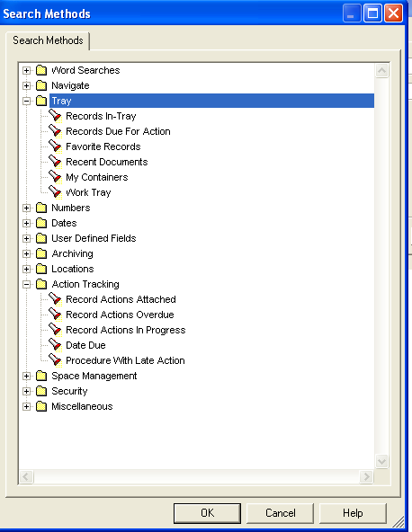
Figure 10. Correspondence or Item Tracking Search

A search can be conducted on one or more of these field values. For example, combining search values for Action and Date Due will increase the search precision.

Saved Searches
When it is necessary to perform the same search more than once A Saved Search is convenient. You can create private saved searches for your use. You can also create public saved searches to share. Go to File/Save Search or Right Click/Search/Save Search and fill in as appropriate. Click ‘next’ to proceed to the next Save Search screen. You can customize your search, making them public or private as required.
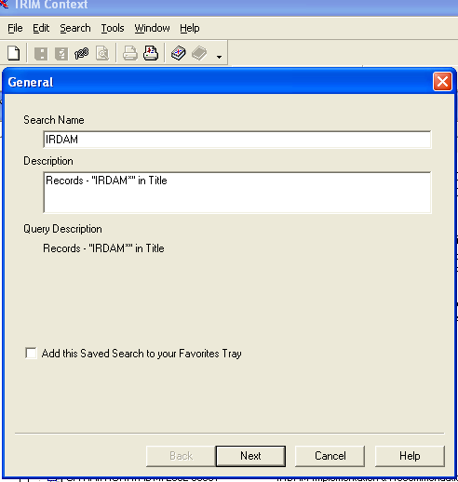

Figure 11. First screen of Saved Searches. Click Next to proceed.

Recall saved searches though the menu path Search and Saved Searches. Once in the Screen titled Select from Saved Searches – All, review the list of saved searches, highlight the desired search. To view rights or remove a Saved Search, right mouse click and choose the appropriate action. Go to Properties to modify and access the appropriate tab.

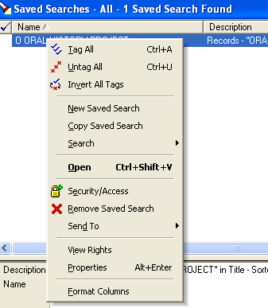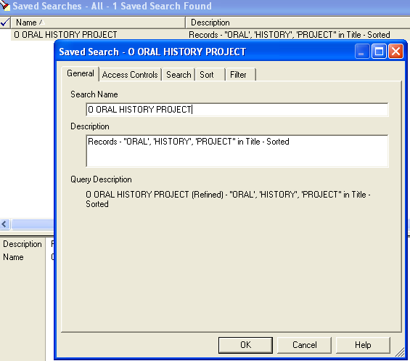

Figure 12. Right Click to Access Saved Search Details. Go to Properties to Modify.

A Saved search can be created from a typical search. Conduct a search and navigate to File and Save As. The Saved Search- New window is presented and you are asked to provide a Name and Description for the search. Complete this information and select Ok to close the creation step. Your search is now available through RAMP-TRIM.

Modifying Item Tracking Assignments
Access Modification Search and highlight a correspondence record. Right Click/Workflow/Browse Actions Proceedures. Some users may not have access to this feature. If tracking processes/actions are present, review the following possible events.

Print Action Sheet Action Sheets contains a description of the correspondence tracking process and each action in the process. Where several actions are required to complete the process this sheet contains bar codes corresponding to each action and will make action monitoring easier.

Change the Responsible Staff Member The staff member designated as responsible for the correspondence task is shown in the field Responsibility Of. Use the KwikSelect to reassign the task. Note that some staff members do not have rights to reassign staff.

Create a New Tracking Action/Process Function Additional tracking processes can be added by using the New function.

Complete/Uncomplete Correspondence Tracking Action/Process You may complete a step in process, or uncomplete a completed step with the buttons Complete or Uncomplete. Note that you may not have access rights to perform these tasks.

Remove Correspondence Tracking Action/Process You may remove a step in the process with the button title Remove. Note that you may not have access rights to perform these tasks.

Attaching Electronic Documents

You may attach a document to a correspondence record by highlighting the record for which the document will be connected to and then Right Click Electronic/Check-In.
Go to Attach and select Local File. Navigate to your document of choice that you wish to attach, click open, then OK to attach the document.
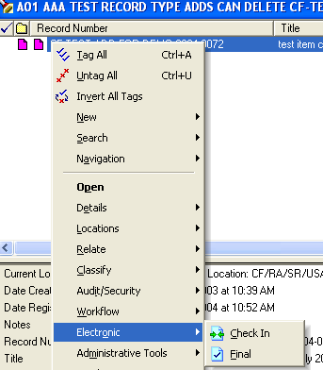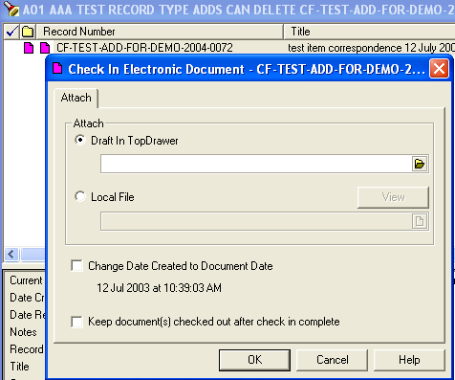
Figure 13. Right Click/Electronic/Check-In Screen/Attach.

Your record will then have a document icon depending upon the program used for the document attached.
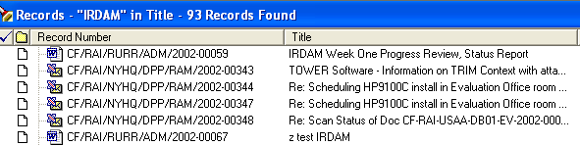

Figure 14. Icon Indicating Word Document and Excel Attachments

Changing Attached Electronic Documents

You can replace the attached document with a different one by right click/Electronic/Check-out/Local and remove the document which is already attached in the field marked File Name by opening the save to disk icon.

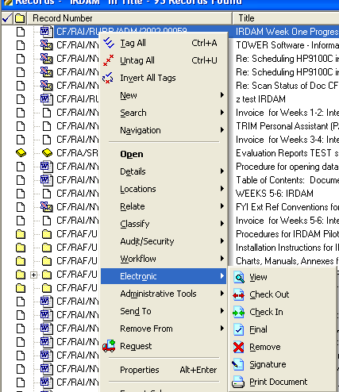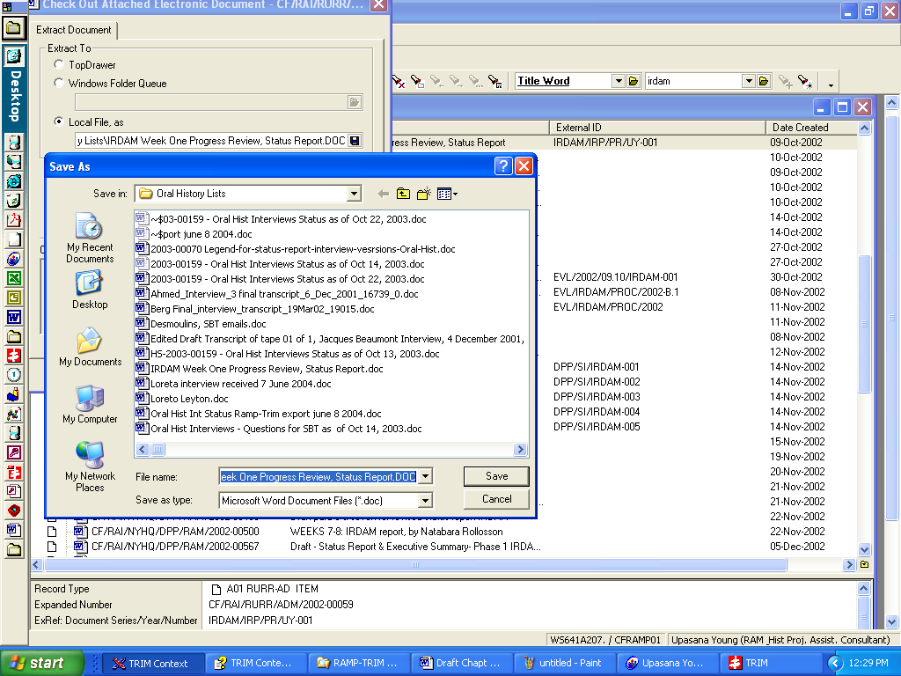
Figure 15. Extracting Document from TRIM to Store

You will now have to go to Task, Electronic, Return and indicate the document that is to replace it, again by selecting Local and opening the yellow folder.
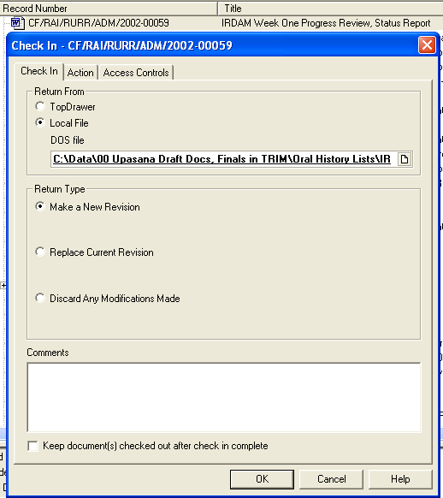

Figure 16. Check-In replacement Document

Printing Item Tracking Reports
Correspondence tracking reports can be printed through the standard report option or the workflow option in RAMP-TRIM. Review the report layout to determine which format best suits your requirements.

Access to Standard Reports Navigate the menu path File and Print Report.

Key Learning points

Required

Register all important items created or received by the work unit.
[Correspondence, reports, working papers]

Recommended

Assign Actions to items
Choose most important items to “contain” in local file folder

Available

Relate Items [similar to placing copies in multiple local subject folders]
Track Actions
Complete or close actions
Print reports and logs

Self-Test: Document Tracking – Part A

- What is the purpose of correspondence tracking?

- Define the following terms: action, process, KwikSelect, and Record View Pane.

- At what point would you select “Complete Current Action” for a correspondence item?

- What are some important fields to search under to find specific correspondence?

- When do you include the document file name [xxx.doc] when creating a correspondence entry?

- In terms of correspondence tracking, what does action refer to?

- When can a tracking process be assigned to a correspondence item?

- How do you register a new correspondence item record?

- What type of information should be entered in the Notes field?

- When should a check mark be placed in the Current field?

- What should you do if you are uncertain of the document status?

- What are the steps to completing the current action in the correspondence tracking tasks?

- What are the steps to reference the current action in the correspondence tracking tasks?

- What are methods that can be used to find the status of correspondence tracking tasks?

- Name search methods to search for correspondence tracking assignments.

- In Modifying correspondence tracking assignments, what are the initial steps to modify a correspondence record?

- How do you change the responsible staff member?

- How do you print a standard report?

- How do you print a tracking report? TO BE TESTED

- How do you modify a correspondence tracking assignment?

Self-Test: Document Tracking – Part B

1. What is the purpose of registering correspondence?

Answer:

2. Define the following terms:

Action:

Process:

Kwik Select:

Record View Pane:

Workflow:

3. At what point would you select “Complete Current Action” for a correspondence item?

Answer:

4. What are some important fields to search under to find specific correspondence?

Answer:

5. When do you include the document file name [xxx.doc] when registering a correspondence entry?

Answer:

6. In terms of correspondence tracking, what does workflow refer to?

Answer:

7. When can a tracking process be assigned to a correspondence item?

Answer:

8. How do you register a new correspondence item record?

Answer:

9. What type of information should be entered in the Notes field?

Answer:

10. When should a check mark be placed in the Current field?

Answer:

11. What should you do when registering a record, if you are uncertain of
its status [whether or not it is a current record]?

Answer:

12. Name three search methods to search for correspondence tracking assignments.

Answers:

1.
2.
3.

13. What are the steps for completing the current action in the correspondence tracking tasks?

Answer:

14. What are the steps to take to see what the current action is for a record that has been assigned a correspondence tracking task?

Answer:

15. What are the two methods that can be used to find the status of correspondence tracking tasks?

Answers:

1.

2.

16. In Modifying correspondence tracking assignments, what are the initial steps to modify a orrespondence record?

Answer:

17. How do you change the responsible staff member?

Answer:

18. How do you print a standard report?

Answer:

19. How do you print a tracking report?

Answer:

Exercises for Practice of Correspondence Tracking

1. Register as an item the following three samples
Correspondence for your Chron Log such as the following memo:

1.a First sample:

To: Computer Focal Point
From: <Yourself>
Subject: Excess nixe from air conditioner in computer training room the following document created by your colleague.

1.b Second Sample:

To: The head of your work Unit
From: <Yourself>
Subject: Our work unit projects for the upcoming month the following memo

1.c Third Sample:

To: Your Division Director
From: <Yourself>
Subject: Annual leave dates for members of our division

2. Assign the following actions to the items in number one above.

3. Process and/or take action as appropriate, in item 1a.

4. Advise head or work unit, in item 1b.

5. For Info Only - no action required, in item 1c.

6. Place each of the items in number one in a container [e.g., folder].

7. Place item number 1a in a folder titled “Computer Training of Staff members.”

8. Place item number 1b in a folder titled “Upcoming Projects.”

9. Place item number 1c in a folder titled “Annual Leave for Division Members.”

10. Complete the Item Tracking Task for each of the previous samples in number one.
Hint: navigate the menu options Task, Complete and Actions.

- Find the status of the Item Tracking Tasks for each of the previous samples in
number 1.
Hint: Highlight the item, and navigate to the All Actions field in the view pane.

12. Modify the item Tracking Tasks for each of the previous samples in number one.
Hint: Assign the task to the person sitting next to you by going to Browse, Actions/
Procedures and Modify.

13. Close the Item Tracking Tasks for each of the previous samples in number one.
Hint: Navigate the menu through Browse, Action/Procedures, Modify and Close.

14. Print the Item Tracking Tasks for each of the previous samples in number one.
Hint: Search for the record and navigate through Process, Report, Workflow Statistics and Print.

Answers to Self-Test Document Tracking, Number 13

- The correspondence and tracking tools are employed to identify scheduled events, overdue events, incoming volume of correspondence and items, or completion of tasks.
- Kwikselect is the folder icon located to the far right of fields with an authority table
- Select complete current action for a correspondence action when you have completed the workflow task (action).
- You might search the author, unit, date created, title on notes field when locating a correspondence item.
- You enter the document file name when the correspondence item is an electronic document (for example, directory/file name, extension, e.g., C:/temp/list.doc.)
- An action, in correspondence tracking, is a task or business step that must be complete before the item is considered completely processed (e.g., review or received, etc.)
- A tracking process can be assigned to a correspondence item at any time.
- Register a new correspondence item through the TRIM menu selection File, New Record, and Item .
- Enter any information that describes the records or contributes to an understanding for the record and its relationship to the business activities.
- Place a check mark in the current field when you are sure the record is current.
- If you are uncertain about a document’s status do not check the box titled certain.
- Complete the current action by finding a record and Right Click/Work Flow/Browse Actions and Procedures or Right Click/Properties/Related Actions tab.
- Reference a current action by finding a record and Right Click/Work Flow/Browse Actions and Procedures.
- To find the status of a correspondence tracking task search and display the record and examine the actions in the lower view pane, or Right Click/Work Flow/Browse Actions and Procedures .
- Search for correspondence tracking assignments by the action name, start date/date- range, due date/date-range, or individual responsible.
- Right click Navigate to Workflow, Browse and Actions Procedures.
- Right Click to Workflow, Browse and Actions/Procedures, open the step, modify, select the fields Responsibility of and change the person.
- Search for records, tag the selected records, navigate to File, Print Report, and select the desired report and print.
- TO BE TESTED FOR CONTEXT. Search for the record select Process, Report, and Workflow.
- Modify the correspondence-tracking item through the Workflow, Browse and right click/Modify functions.

